# Using Law of Sines to Solve Oblique Triangles

Any triangle that is not a right triangle is an oblique triangle. Solving an oblique triangle means we need to find all the measurements of all three angles and all three sides. There are three possible oblique triangle situations:    

1. ASA (angle-side-angle): This is where we know the measure of two angles and the side between them.

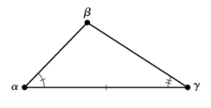

1. AAS (angle-angle-side): This is where we know two angles and a side that is not between the known angles.

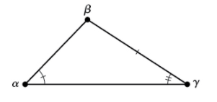

1. SSA (side-side-angle): This is where we know two sides and an angle that is not between the known sides.

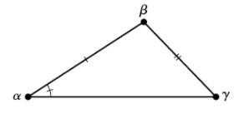

Given a triangle with angles and opposite sides, as shown below,

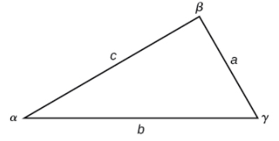

the ratio of the measurement of an angle to the length of its opposite side will be equal to the other two ratios of angle measure to opposite side. All proportions will be equal. The **Law of Sines** is based on proportions and is presented symbolically two ways.

$$\frac{\sin{α}}{a}=\frac{\sin{β}}{b}=\frac{\sin{γ}}{c}$$

$$\frac{a}{\sin{α}}=\frac{b}{\sin{β}}=\frac{c}{\sin{γ}}$$

To solve an oblique triangle, use any pair of applicable ratios.

Examples

1. Solve each of the triangles. Round to the nearest tenth.
   * + 1. 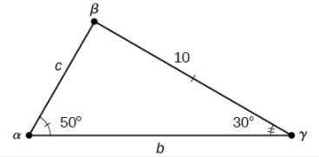
       2. 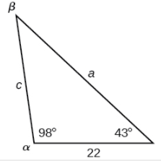
2. Use the Law of Sines to find the missing side for the oblique triangle. Round each answer to the nearest hundredth. Assume that angle $A$ is opposite side $a$, angle $B$ is opposite side $b$, and angle $C$ is opposite side $c$.

Find side $b$ when $A=37°$, $B=49°$, $c=5$

# Using the Law of Sines to Solve SSA Triangles

We can use the Law of Sines to solve any oblique triangle, but some solutions may not be straightforward. In some cases, more than one triangle may satisfy the given criteria, which we describe as an ambiguous case. Triangles classified as SSA (side-side-angle), can result in zero, one, or two solutions, as shown below.

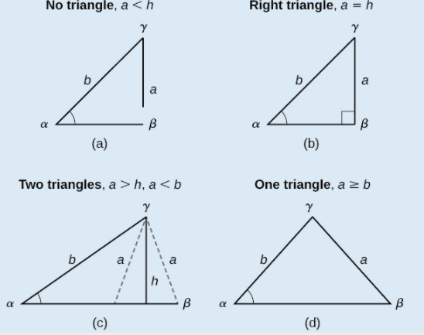

Examples

1. Solve each of the following triangles. Round all measurements to the nearest tenth. Be sure to check for multiple solutions.
   * + 1. 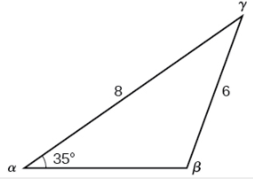
       2. 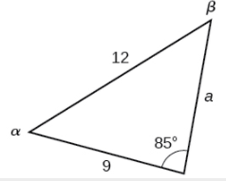
2. Find all possible triangles if one side has length $4$, opposite an angle of $50°$, and a second side has length 10.

# Finding the Area of an Oblique Triangle Using the Sine Function

Now that we can solve a triangle for missing values, we can use some of those values and the sine function to find the area of an oblique triangle.

The **formula for the area** of an oblique triangle is given by

$$\text{Area}=\frac{1}{2}bc\sin{α} \\ =\frac{1}{2}ac\sin{β} \\ =\frac{1}{2}ab\sin{γ}$$

This is equivalent to one-half of the product of two sides and the sine of their included angle.

Examples

1. Find the area of a triangle with sides $a=90$, $b=52$, and angle $γ=102°$. Round the area to the nearest integer.
2. The Bermuda triangle is a region of the Atlantic Ocean that connects Bermuda, Florida, and Puerto Rico. Find the area of the Bermuda triangle if the distance from Florida to Bermuda is $1030$ miles, the distance from Puerto Rico to Bermuda is $980$ miles, and the angle created by the two distances is $62°$.

# Solving Applied Problems Using Law of Sines

We can apply the Law of Sines to solve situations involving oblique triangles.

Examples

1. Find the altitude of the aircraft in the diagram below. Round the altitude to the nearest tenth of a mile.

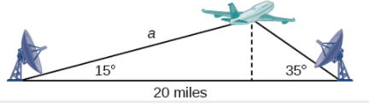

1. The diagram below represents the height of a blimp flying over a football stadium. Find the height of the blimp if the angle of elevation at the southern end zone, point $A$, is $70°$, the angle of elevation from the northern end zone, point $B$, is $62°$, and the distance between the viewing points of the two end zones is $145$ yards.

